INTERNAL COMPONENT OF RC CAR: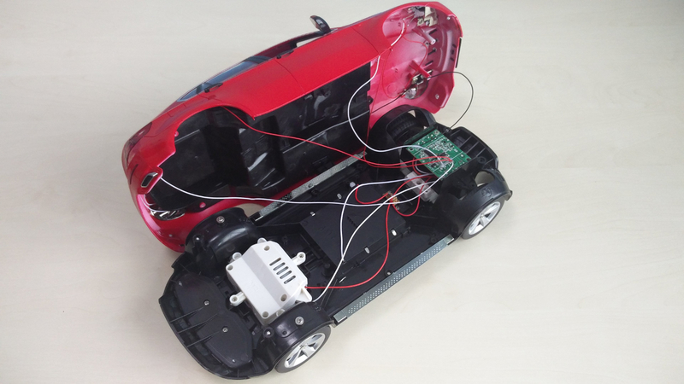
Introduction:
An RC car's internal components power its movement and steering, primarily consisting of a Battery, Motor (brushed or brushless), Electronic Speed Controller(ESC) to manage motor speed, a Steering Servo for turning, and a Receiver that translates signals from the remote (transmitter) to these parts, all built on a structural Chassis with a Suspension system for handling.
INTERNAL BLOCK WORKING DIAGRAM:
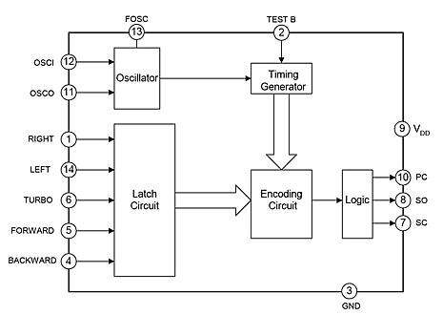

Electronic Components
These parts manage the control and power of the vehicle.
- Receiver (Rx): This unit is mounted inside the car and receives radio signals from the handheld transmitter (controller). It converts these signals into commands for the other electronic components.
- Electronic Speed Controller (ESC): In electric RC cars, the ESC controls the motor's speed and direction by regulating the power from the battery.
  - Types:
    - Brushed ESC: Used with older, less efficient brushed motors.
    - Brushless ESC: Used with modern, more efficient, and powerful brushless motors; these are more complex as they need to manage power across three motor wires.
- Servos: These are small, geared motors used for steering. In nitro cars, an additional servo controls the throttle and braking.
  - Types: Vary by size (micro, standard, low-profile) and torque ratings (e.g., kg-cm of force).
- Batteries: The power source for electric cars and the electronics in nitro cars.
  - Types: The most common rechargeable types are Nickel-Metal Hydride (NiMH) and high-performance Lithium Polymer (LiPo), the latter requiring specific charging safety precautions.
- Motor (Electric RC): The component that converts electrical energy into mechanical motion.
  - Types:
- Brushed Motors: Cheaper, simpler, and suitable for beginners, but less efficient and have a shorter lifespan due to brush wear.
- Brushless Motors: More efficient, powerful, and durable, typically used in high-performance or competition RC cars.

Drivetrain Components
The drivetrain transfers power from the motor/engine to the wheels, enabling movement.
Transmission: A system of gears that adjusts the gear ratio between the power source and the wheels, balancing speed and torque.
Gears:
Pinion Gear: A small gear attached directly to the motor shaft.
Spur Gear: A larger gear that the pinion meshes with.
Differential: This critical component allows the wheels on the same axle to rotate at different speeds, which is essential for smooth turning.
Driveshafts/Drive belts: These parts transmit power from the transmission/differential to the actual wheels.
Clutch (Nitro RC): In nitro cars, a centrifugal clutch engages the transmission as the engine speed increases.
Chassis and Suspension
The chassis is the foundation, and the suspension system absorbs impacts and maintains traction.
- Chassis: The main frame of the car that holds all other components.
  - Types:
    - Ladder Frame: A strong, traditional design using connected beams.
    - Monocoque: A single-piece design that is lightweight and rigid, common in high-performance cars.
    - Tub Chassis: Features a flat base with raised sides for component protection, often used in off-road vehicles.
- Suspension System: Includes shock absorbers, springs, and A-arms, designed to handle varying terrain and keep the tires in contact with the ground.
- Tires and Wheels: Different types of tires and treads are used for specific surfaces (e.g., slick tires for on-road racing, knobby tires for off-road dirt).
- Body Shell: While external, it protects the internal components from dust, rocks, and moisture.

2. Internal Components of an RC Car

2.1 Battery Pack
Types:
- Nickel-Metal Hydride (NiMH)
- Lithium-ion (Li-ion)
- Lithium Polymer (Li-Po)
Function: Supplies electrical power to the motor, receiver, Electronic Speed Controller (ESC), and servo motor.

2.2 Electronic Speed Controller (ESC)
Function:
- Controls motor speed and direction (forward/reverse)
- Regulates power from battery to motor
2.3 DC Motor / Brushless Motor
Types:
- Brushed DC Motor
- Brushless DC Motor (BLDC)

2.4 Receiver (Rx)
Function:
- Receives radio signals from transmitter
- Sends control signals to ESC and servo motor
Frequency Bands:
- 27 MHz
- 49 MHz
- 2.4 GHz (most common)

2.5 Transmitter (Tx) – External but Essential
Function: Sends control commands (speed, direction, steering) to the receiver using radio waves.

2.6 Servo Motor (Steering Servo)
Function:
- Controls left and right steering of front wheels
- Converts electrical signal into precise angular motion

2.7 Gearbox / Transmission System
Components:
- Pinion gear
- Spur gear
- Differential gear
Function: Transfers motor rotation to wheels with required torque and speed.

2.8 Chassis
Function:
- Mechanical base to mount all components
- Provides structural strength
Materials:
- Plastic
- Aluminum
- Carbon fiber

2.9 Wheels and Suspension System
Function:
- Wheels convert rotation into vehicle movement
- Suspension absorbs shocks and maintains stability

3. Types of RC Cars (Based on Internal System)

3.1 Electric RC Car
- Powered by rechargeable batteries
- Uses DC or brushless motor
- Quiet and easy maintenance

3.2 Nitro (Fuel-powered) RC Car
- Uses internal combustion engine
- Servo-controlled throttle and brake
- More mechanical complexity

3.3 Toy-grade RC Car
- Integrated PCB (receiver + ESC + controller)
- Limited speed and range

3.4 Hobby-grade RC Car
- Separate ESC, receiver, motor, and servo
- High performance and modular design

4. Working Flow Chart of RC Car (Overall)
Flow Chart 1: Signal Flow
User Input (Joystick / Trigger)
↓
Transmitter (Tx)
↓ Radio Signal
Receiver (Rx)
↓
Electronic Speed Controller (ESC)
↓
Motor Rotation
↓
Gear System
↓
Wheel Movement

5. Steering Control Flow Chart
User Turns Steering Control
↓
Transmitter
↓
Receiver
↓
Servo Motor
↓
Steering Linkage
↓
Front Wheels Turn Left / Right

6. Power Distribution Flow Chart
Battery Pack
↓
Power Distribution Circuit
↓
ESC Receiver
↓
Motor Servo Motor

7. Motor Control Flow Chart
Receiver Signal
↓
ESC PWM Control
↓
Motor Speed Regulation
↓
Torque Output
↓
Vehicle Speed Control
The internal components of an RC car's remote control system are split between the handheld transmitter and the receiver unit inside the car. The car may also use various sensors for advanced functions like obstacle avoidance or data telemetry
Handheld Remote Control (Transmitter):
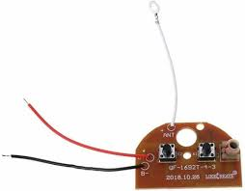

The remote control is where the user input is generated and converted into wireless signals. Key internal components include:
- Printed Circuit Board (PCB): The main board that connects all the electronic components.
- Microcontroller/Encoder Chip: This acts as the "brain," processing button or joystick movements and encoding these commands into a specific signal format (e.g., radio frequency or infrared).
- Input Components:
- Buttons/Joysticks: The physical interfaces for user control (steering, acceleration, etc.).
- Potentiometers: Often connected to joysticks to provide variable input levels (e.g., for smooth speed control).
- RF Transmitter Module: Generates and sends the encoded signal via radio waves at a specific frequency (e.g., 27 MHz, 2.4 GHz).
- Antenna: A wire or rod that efficiently radiates the radio signals into the air.
- Power Supply: Typically a battery pack (e.g., AA batteries) to power the circuit.
RC Car (Receiver Unit & Control System)
The car contains the components that receive the signal and translate it into physical movement:
- Receiver Module: Captures the wireless signals from the transmitter via its own antenna.
- Decoder Chip/Microcontroller: Decodes the incoming signal packets and translates them into commands for the motors and steering.
- Electronic Speed Controller (ESC): This is a crucial component that takes the control signals and manages the power from the main battery to the drive motor(s), controlling speed and direction.
- Microprocessor: The "brain" of the ESC that interprets the signal and controls the power delivery timing.
- Power MOSFETs (Transistors): Act as high-speed switches to pulse the power to the motor coils, enabling variable speed control and efficiency.
- BEC (Battery Eliminator Circuit): A built-in voltage regulator that provides a stable, lower voltage (typically 5V-7.4V) from the main battery to power the receiver and servos, eliminating the need for a separate power source for these components.
- Servos: Geared motors that use feedback (often from an internal potentiometer) to move the steering mechanism to a specific position based on the receiver's command signals.
- Drive Motor(s): The main motor (brushed or brushless) that propels the car forward or backward.
Optional Sensor Devices
More advanced or custom-built RC cars may incorporate various sensors, which typically include a basic circuit board with a transducer and processing components:
- Ultrasonic Sensors: Used for obstacle detection and avoidance, working by emitting sound waves and measuring the time it takes for them to return.
- Infrared (IR) Sensors: Also used for obstacle avoidance or line-following; they work by detecting reflected infrared light.
- Accelerometers/IMUs: Measure the car's acceleration, position, and orientation, providing data for stability systems or telemetry back to the user.
- Temperature Sensors: Monitor the temperature of critical components like the motor or ESC to prevent overheating.
- The integration of these components allows for complex and responsive remote operation and even autonomous features.

